Project no. 178013/I30
PROJECT REPORT
Geological Storage of CO2: Mathematical Modeling and Risk Assessment (MatMoRA)
Helge K. Dahle, Knut-Andreas Lie and Jan M. Nordbotten

Lead institutions:

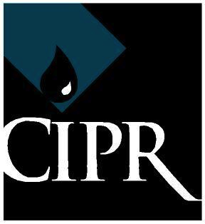

Research Partners:



Sponsors/Industry partners:



CONTENT

1 INTRODUCTION __________________________________________ 4

2 MAIN RESULTS ____________________________________________5

2.1 Vertical Equilibrium __________________________________________ 6
2.2 Dissolution of CO2 in brine __________________________________ 8
2.3 Development of computational methods and
simulation software ______________________ 9
2.4 Benchmarks __________________________________________________ 10
2.5 International collaboration and workshops _____________ 11

3 RECOMMENDATIONS __________________________________ 12

4 WORKPACKAGES _______________________________________ 13

WP1: Convective Mixing in Heterogeneous Media _____________ 13
WP2: Asymptotic Analysis of Two-Fluid Flow in Statistically
Homogeneous Fractured media _____________________________ 14
WP3: Streamline Technology for CO2 Flow in Fractured and
Faulted Media _________________________________________________ 14
WP4: Implementation and Code Development _________________ 15
WP5: Risk Assessment ___________________________________________ 16

5 FUTURE ___________________________________________________ 17

APPENDIX: Publication Report ___________________________ 18

1 INTRODUCTION

The MatMoRA-project was initiated in 2007 as a KMB-project (research project with user participation) financed by the Research Council of Norway, Statoil, Norsk Hydro, and Norske Shell. During the project period, Norsk Hydro and Statoil merged to one company, and is today Statoil.

The main objective of the project was “…to develop analytical and numerical tools to be used in risk assessment analysis of geological storage of CO₂….”.

Defined research tasks were to “…develop fast methods to assess and characterize storage capacity in possibly fractured and/or faulted media […] consider structural and residual trapping mechanisms and dissolution processes, while mineral trapping and geomechanical fracturing is beyond the scope of the proposal…”

The project has been managed by three principal researchers:

- Professor Helge K. Dahle, Department of Mathematics, University of Bergen
- Chief scientist Knut-Andreas Lie, SINTEF IKT (Professor II, University of Bergen)
- Professor Jan M. Nordbotten, Department of Mathematics, University of Bergen

A steering committee was established from the outset of the project with representatives from research and industry partners. The leader of the steering committee has been Benedicte Kvalheim (Head of Department, IOR studies, Statoil). In 2011, the committee consists of:

- Benedicte Kvalheim, Statoil (leader)
- Jostein Haga, Norske Shell
- Martin Iding, Statoil
- Roger Bjørgan SINTEF IKT
- Aage Stangeland, Forskningsrådet/CLIMIT (observer)
- Ivar Aavatsmark, Uni CIPR
- Jan M. Nordbotten, University of Bergen
- Knut-Andreas Lie, SINTEF IKT
- Helge K. Dahle, University of Bergen

The steering committee has met twice per year, and has been invaluable in giving advice and direction to the scientific management of the project.

The project has contributed greatly to the understanding of the dynamics and behavior of CO2 stored in geological formations and has been successful in producing scientific outputs as documented in the attached publication report. Through publications in peer-reviewed scientific journals, conference participation, conference organization, education of master and PhD-students, and building international networks, the project has achieved the ambitions of the original project proposal. In particular, the project has also been crucial for establishing new research activities (including in part the RCN-funded projects FME SUCCESS, IGEMS, VAMP, and Numerical CO2 laboratory; the international research training program NUPUS; and the Princeton-Bergen SIU project on modeling of CO2 storage).

In this report, the main results from the project are given and some recommendations are provided, both with regard to best practices and further research directions. The main activities within the five work packages outlined in the project proposal are then briefly described.

2 MAIN RESULTS

In this section we briefly give some highlights from the project. The main findings are listed below and are related to the work packages (WP1-WP5) described in the original proposal and in Section 4:

- Depth-integrated models based on vertical-equilibrium (VE) assumptions are efficient and accurate upscaling on the length and time-scales relevant for CO2 storage. (WP3, WP4).
- The presence of a capillary fringe increases the rate of enhanced convective dissolution significantly, while reducing the horizontal migration speed of free CO2. (WP1, WP3, WP4).
- Streamline simulation can be very effective for studying early-stage injection and engineered solutions when the flow dynamics is dominated injection/production of fluids. Streamlines can also be used to simulate long-term migration (and the transition from injection-dominated to gravity-dominated flow), but may become quite inefficient because of gravity-induced rotations in the total velocity field (WP3).
- Numerical simulation capabilities have been developed both in the form of research simulators as well as open-source toolkits that facilitate easy implementation of 2D and 3D formulations. In particular, simulation of field-case scenarios using VE-formulations is operational and available as open-source software (WP3, WP4).
- To build confidence and gain experience, the research community has engaged in multiple benchmarking and inter-comparison efforts. The project has initiated two benchmark studies:
  - The Stuttgart benchmark clearly demonstrated the significant uncertainty that lies in the choice of flow models. The benchmark also showed that expert mistakes, which are seldom regarded as an uncertainty factor, may contribute significantly to the model uncertainty. To be credible, model-based decisions about storage operations should therefore not rely on a single team of experts.
  - The Svalbard benchmark demonstrated that: (i) (fully) resolved 3D simulations may be hard to obtain even for highly idealized model setups, and (ii) that simplified models with reduced physics may provide more reliable predictions.
In addition, the project has developed a family of models of the Johansen formation which have been made publicly available. (WP4, WP5).

2.1 Vertical Equilibrium

The long-term migration of CO2 is typically taking place in a medium where the length scale is significantly larger than the vertical scale. In such cases, it is quite common in science to use a depth-averaged model in which the vertical movement of the fluids is eliminated from the effective equations. Indeed, because of the density difference between CO2 and brine, the injected CO2 will quickly rise to the caprock and segregate from the resident brine. The CO2 will then continue to migrate as a plume below the caprock, under the influence of gravity and advective forces. This dynamics suggests that pressure gradients will become almost hydrostatic after the plume has developed, so that vertical equilibrium can be assumed. This assumption is very attractive because it gives

- Equations amenable to analytical treatment.
- Significant computational savings because of reduced dimensionality but also because of longer time constants and less coupling between physical effects in the model.
- Infinite resolution in the vertical direction.

Because of the great computational savings in making this approximation, models based on VE-assumptions are very useful in risk assessment and inverse modeling and have been used extensively in the project. In particular, a series of benchmarks have demonstrated that models based on the VE-assumptions compare favorably with fully three-dimensional simulations.

Below, we show two figures produced in the project. Figure 1 demonstrates how a vertical refinement makes a set of Eclipse simulations “converge” to the results obtained from a VE-simulation for a vertical cross-section of the Johansen formation. Figure 2 shows how vertical-equilibrium simulations may be history matched “by hand” to fit seismic data from the Utsira formation.

The work summarized in this section can be found in published references [4, 9, 13, 15, 17, 21, 22, 23, 24, 26, 29, 30, 34, 35, 39, 41, 42, 43, 44, 45, 47].
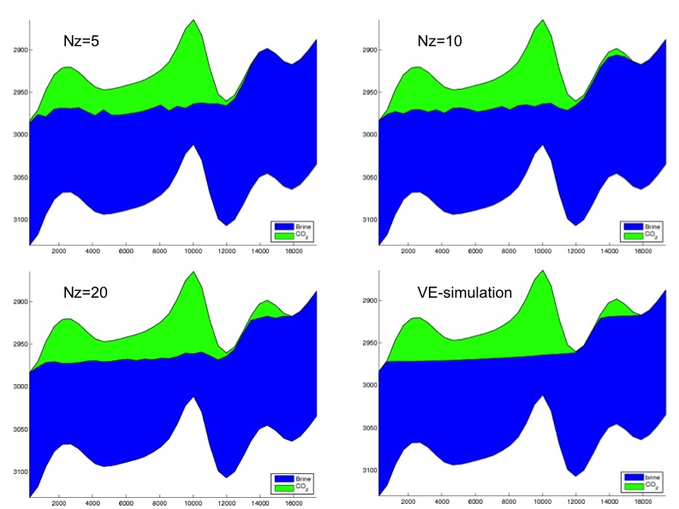

Figure 1: Eclipse simulations on models with 5, 10, and 20 vertical layers compared with a Vertical Equilibrium simulation for a cross-section of the Johansen formation, with green color representing CO2 and blue is brine.(http://www.sintef.no/Projectweb/MRST/Gallery/CO2-storage/)

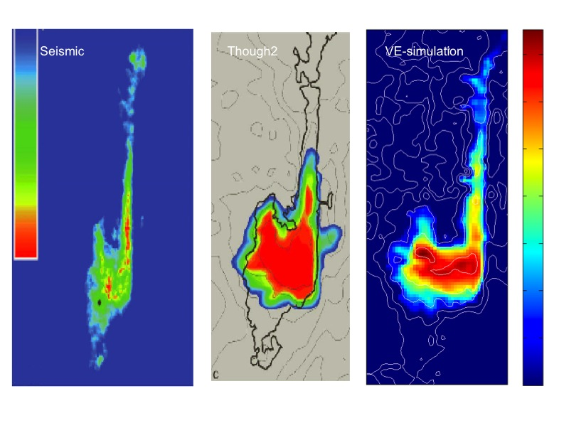
Figure 2: Comparisons of seismic image of CO2-plume in the Utsira formation, simulations based on Though2, and history-matched results based on Vertical Equilibrium simulations. The seismic image and the TOUGH2 simulation are from Chadwick, Noy, Arts, and Eiken, Energy Procedia (2009). 2103-2110. See: http://www.sintef.no/Projectweb/MRST/Gallery/CO2-storage/ for the VE-simulation.
2.2 Dissolution of CO2 in brine

CO2 dissolves into brine and saturates at values of a few percent per volume. While molecular diffusion is sufficient such that the phases can be considered in equilibrium locally (at the so-called REV scale), it is not sufficient to induce significant dissolution beyond the two-phase region. However, because of CO2 saturated brine being denser than the ambient brine, convective mixing may be triggered that significantly enhances the dissolution by transporting saturated brine away from the two-phase region.

Our research into this topic is two-fold. While previous studies considered only the convective transport of CO2 in the brine phase, our analysis has extended previous analysis to include the effect of the two-phase region above the pure brine region. For typical parameters, this leads to an enhancement of the effective rate of convective mixing, as shown in Figure 3.

Figure 3: Comparison of effective mixing rates. The early time is diffusion dominated, while at later time we see that the two-phase analysis (solid lines) predicts earlier and stronger mixing than the single-phase case. Elenius et.al. (2011).
Our second research track into this topic is the development of vertically- integrated models that account for convective mixing. In these models, results such as those shown in Figure 3 represent input data for large-scale simulation. Typical results are shown in Figure 4. Applications of this model to full-field data such as the Johansen data set from the Stuttgart benchmark compare favorably to full 3D simulations.

The work summarized in this section can be found in published references [24, 27, 28, 34, 36, 42].

Figure 4: Development of a mobile CO2 plume (black) under a sloping caprock, where we observe the formation a residually trapped CO2 (dark grey) and a region of upscaled convective mixing (light gray); Gasda et al. (2011)

2.3 Development of computational methods and simulation software

Modeling the physics of CO2 storage poses major challenges to contemporary numerical tools, which to a large extent are based upon methodologies developed in the petroleum industry. Existing software can in many cases not provide answers to important questions. To improve confidence in simulation results, a collective research effort is needed to provide transparent and verifiable software solutions that are not proprietary to any specific company. Our project has contributed in this direction by developing open-source software for VE-simulations. Moreover, as part of our wider activity, the project partners have released basic flow and transport solvers and functionality for reading and processing industry-standard input formats that may help others to develop or test their methods for realistic data.

A large number of in-house research codes have also been developed in the project (streamline solvers, pressure solvers, semi-analytical models, etc) that may be available upon request, when appropriate. In Figure 5 we have shown an example calculation obtained from the Matlab Reservoir Simulation Toolbox (MRST, http://www.sintef.no/mrst).

Simualtion development and related research on appropriate discretization and linear solvers is described in published references [1, 3, 4, 5, 6, 7, 9, 13, 14, 15, 18, 20, 24, 25, 31, 41, 43, 45, 47, 48].

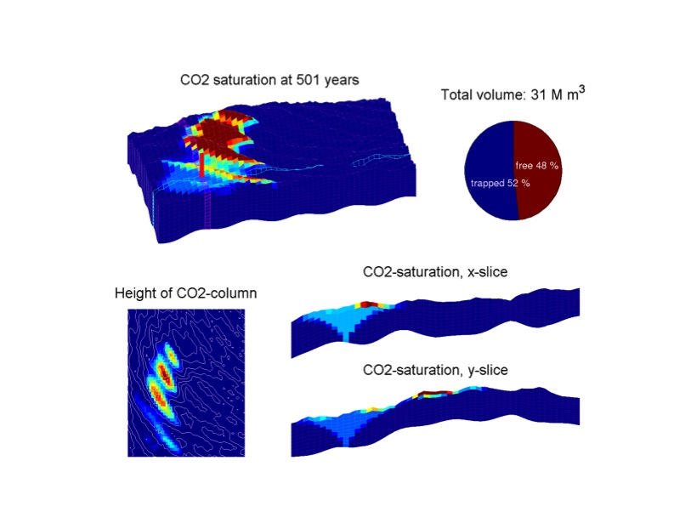

Figure 5: Example calculation from the MRST-toolbox showing the effect of caprock topography (http://www.sintef.no/Projectweb/MRST/Modules/VE-Tutorials/).

2.4 Benchmarks

The project has had a sustained effort towards contributing to the development of a suite of benchmark problems of high relevance to the CO2 modeling community. These were presented as:

- Johansen Dataset: Developed in collaboration with the Norwegian Petroleum Directorate. The full-field data for the Johansen field is available from the MatMoRA website as a test-case for CO2 storage modeling.
- Stuttgart Benchmark: In collaboration with our project partners at the University of Stuttgart, three benchmark problems were presented and studied. Initial discussions were conducted in the frame of a workshop, which resulted in a special issue of Computational Geosciences (one of the main journals in the field), and summary publication.
- Svalbard Benchmark: First presented at the SIAM Geosciences conference in Leipzig, this benchmark study was discussed in detail at our conference on Svalbard, August 2009. A publication describing the benchmark results will appear later.
The two first studies have been published as [11, 12].
The modeling community has positively received all benchmark studies, with strong participation from US and European groups. As an example, we present results from the first of the three problems that compose the Stuttgart Benchmark in Figure 6.

Figure 6: The figure illustrates predicted leakage from a faulty well connecting a storage aquifer with a shallower aquifer. For this problem, where compressible and thermal effects were neglected, strong agreement was found between all participating groups. When problem complexity increases, the quantitative agreement deteriorates; Class et al. (2009).

2.5 International collaboration and workshops

Through the MatMoRA-project, the research group has improved pre-existing international collaborations and developed new ones. Most important has been the collaboration with professor Michael A. Celia’s research group in Princeton, and professor Rainer Helmig’s group at the University of Stuttgart. Both are prominent researchers in the international modeling community on flow and transport in porous media. These collaborations have led to numerous student exchanges and joint workshops on CO2 storage. In particular, the project group has played a key part in organizing:

- Workshop on numerical models for carbon dioxide storage in geological formations, Stuttgart, Germany, 2-4 April, 2008
- Modeling and risk assessment of geological storage of CO2, Longyearbyen, Svalbard, August 3-7, 2009
- Scales of resolution, model complexity, and solution approaches for CO₂ storage problems, December 6-7, 2010, Princeton.
- Averaging, upscaling and new theories in porous media flow and transport, October 14-15, Bergen.
- Mini-symposium: Problem oriented solution strategies for geologic CO₂ storage, SIAM Geosciences Conference, June 15-18, 2009, Leipzig.
- Workshop on numerical discretization and upscaling methods, Nov. 1-2, 2007, Princeton.
- Mini-symposium: Applications of self-similar solutions to porous media flow, SIAM Geosciences conference, 2007, Santa Fe.

Our three PhD-students have all had extended stays with collaborating researchers:

- Leonid Vasiliev has spent one month with Professor George Pinder at University of Vermont in 2008. In 2010, he spent another month with professor Majid Hassanizadeh at Utrecht University.
- Maria Elenius spent 6 months visiting professor Hamdi Tchelepi at Stanford University in 2009/2010.
- Meisam Ashraf is visiting University of Stuttgart for five months in 2011.

Through the project and other funding, we were able to attract Dr. Karsten Preuss to an adjoint professorship at the University of Bergen in 2009 and 2010.
Dr. Preuss is a world leader in computational modeling of CO2 migration, and is the originator of the TOUGH-code.

The project group has become a member of the International Research training Group on Non-linearities and Upscaling in PoroUS Media (NUPUS). This is a study program which aims at fostering a coherent combination of education of and research by young scientists. The program aims to combine fundamental research (e.g. the development of stochastic methods and basic theories of flow and transport in porous media) and research on the optimization of efficient numerical schemes interlinked with applied research in various fields. An application of particular interest in this program is geological storage of CO2. Currently, the main institutions are the University of Stuttgart, University of Utrecht, and University of Bergen, with a number of collaborating universities and institutions.

3 RECOMMENDATIONS

In the following, we will make some recommendations based upon new findings and research results from the project:

- Simulators based on VE-assumption give fast and accurate alternatives to “full physics” simulators like Eclipse, and appear to be more viable than invasion-percolation type methods. Vertical Equilibrium may in particular be useful in giving fast estimates of plume evolution and migration, and will be useful in risk type calculations.
- Trapping of CO2 because of dissolution into the wetting phase seems to be more important than previous investigations suggest. However, the results obtained in our investigation may be dramatically altered if heterogeneity and layers are included in the analysis. Dissolution stands out as one of the more important trapping mechanisms, together with structural and residual trapping, and needs to be investigated further to establish effective dissolution rates.
- Because of gravity segregation and the large viscosity ratio, CO2 will form a thin zone under the caprock. This CO2-plume will continue to migrate under the caprock barrier, unless trapped by capillarity, dissolution, geochemical effects, anticlines or other dome-like caprock structures. Recently, we have shown that the importance of the structure of the caprock has been greatly underestimated when analyzing storage security. In particular, subscale roughness have important effect on the migration speeds.
- Benchmark studies indicate that coarse 3D simulators, both academic and commercial, may have significant bias in their results, leading to unreliable predictions. This effect is emphasized when conducting long-term studies.
- Uncertainty related to storage formation performance arises as a consequence of a range of sources: The Svalbard Benchmark indicates that in-house sensitivity studies greatly under-estimate true uncertainty.
- Significant funding for basic research is still required to answer fundamental questions not readily uncovered by operational studies.

4 WORKPACKAGES

WP1: Convective Mixing in Heterogeneous Media

The original proposal states that “This subproject is thus dedicated to understanding the impact of fractures on the critical time for onset of convective mixing”.

- Principal investigators: Jan M. Nordbotten and Klaus Johannsen (Uni BCCS)
- Students:
  - PhD student Maria Elenius plans to defend her thesis in June2011. (Local advisory committee: Johannsen, Nordbotten. Dahle).
  - Master student Trine Mykkeltvedt graduated in June 2010.
- The activity was strengthened through collaboration with Karsten Pruess (LBNL) and Hamdi Tchelepi (Stanford)
- PhD student Maria Elenius visited Stanford University for an extended stay October 2009-April 2010.

The main activity in this work package has been to establish effective dissolution rates at the grid-scale of computations. Because of the inherent difficulty of the problem, the research shifted from studying effects of fractures/faults, towards effect of a capillary fringe. Main findings are reported in Section 2.2.

WP2: Asymptotic Analysis of Two-Fluid Flow in Statistically Homogeneous Fractured media

The project aim was to develop multi-continua models that could adequately handle fractured media.

- Principal investigator: Jan M. Nordbotten.
- Student: Leonid Vasiliev (Local advisory committee: Nordbotten, Dahle).
- Activity was strengthened through visits to George Pinder’s group (Univ. of Vermont) fall 2008 and Majid Hassanizadeh at Utrcht University.
- Activity collaborates with geothermal project POGE in developing understanding for fractured media.

The main research activity has been to identify a relationship that allows Contiuous Time Random Walk models to be re-cast as multi-continua models, and to develop understanding of dispersion processes through the use of network simulation. In our collaboration with the POGE project, numerical discretization methods for handling discrete fractures have also been developed.

WP3: Streamline Technology for CO2 Flow in Fractured and Faulted Media

The original idea of the work package was to investigate the use of streamline methods as an efficient simulation method for both the injection and the migration phase. In particular, the proposal stated that “it is extremely important to asses the performance of the gravity splitting, and if necessary develop improved formulations”.

Early activity in the project focused on developing streamline simulation capabilities for realistic reservoir geometries (in particular, corner-point grids) as well as development of efficient front-tracking methods for slightly compressible flow and segregation along gravity lines. Likewise, relying on the operator splitting and physical assumptions underlying streamline simulation, we developed highly efficient causality-based nonlinear solvers that render standard finite-volume discretizations as efficient as streamline methods. These solvers were used to obtain converged solutions for the Svalbard benchmark.

Extensive numerical studies showed that gravity-induced circulations are formed in the total velocity field for typical injection scenarios and this renders streamline methods, and other methods based on the same assumptions and operator splitting, quite inefficient for the study of long-term migration dominated by gravity. In particular, we have shown that the flow dynamics can be divided into three different physical effects: irrotational advection, solenoidal advection, and gravity segregation. This decomposition naturally leads to an improved gravity splitting, and can also be used to determine when a streamline-type method will be efficient.

Most of the research has been conducted by postdoc Halvor Møll Nilsen, assisted by Knut-Andreas Lie and Jostein R. Natvig (SINTEF). Early in the project, two PhDs were educated on related topics

- Håkon Hægland: Streamline methods with application to flow and transport infractured media,
- Birgitte Eikemo: Fast and accurate solutions of reservoir transport equations on large grid models.

Compared with the original proposal, the activity on streamline methods was reduced in favor of depth-integrated methods, which we consider as more promising for migration studies.

WP4: Implementation and Code Development

Most research in the project has required development of computer code in one of the following two categories:

- Research-grade prototype codes to support in-house testing of a certain hypothesis or to demonstrate advantages of a computational method.
- Robust and reliable codes for use beyond the project period.

The latter category was the focus of WP4, for which the original proposal stated the following goal: “Development of streamline methodology to model CO2 transport in heterogeneous and fractured/faulted media”.

Early in the project, accurate and robust pressure solvers as well as infrastructure and capabilities for reading and processing industry-standard input formats (Eclipse input files) were developed. The later was particularly important to enable the research group to conduct model studies on real data. Moreover, we developed streamline solvers for Cartesian and corner-point grids, as well as efficient finite-volume solvers. All these codes are available as in-house simulator tools. However, for reasons discussed above, we chose to not bring these codes to a maturity level suitable for public release.

Halfway through the project, the Open Porous Media (OPM) initiative was launched as a joint undertaking between Statoil, SINTEF, University of Bergen, and German research partner. The purpose of the OPM initiative is to develop an open-source simulation suite that is capable of modeling industrially and scientifically relevant flow and transport processes in porous media and bridge the gap between the different application areas including reservoir mechanics and CO2 sequestration.

As a consequence, the work in WP4 was aligned with other OPM activities. Good components from the in-house codes have been further refined and have partially been released through OPM and partially through the Matlab Reservoir Simulation Toolbox (MRST), developed by SINTEF. This development will continue through the “Numerical CO2 laboratory” project, which is a direct spin-off from MatMoRA, funded by Statoil and the Research Council of Norway. On April 11, 2011, the project released an MRST module for simulating vertical-equilibrium models. This is the first release in the project.

Key researchers:

- Halvor Møll Nilsen (postdoc. 1), Knut-Andreas Lie, Jostein R. Natvig, Ingeborg S. Ligaarden, and Bård Skaflestad (SINTEF researchers)
- Paulo Herrera (postdoc. 2), Helge K. Dahle, and Jan M. Nordbotten.

WP5: Risk Assessment

Throughout the project, it became clear that geological uncertainty may have a more pronounced effect on the risk assessment than what was appreciated at the outset of the project. As a result, we decided to initiate a study of geological uncertainty. To this end, we sub-contracted researchers from the Norwegian Research Centre to be able to utilize data and their extensive expertise from the previous SAIGUP project, which studied the impact of geological uncertainty on production forecasts of shallow-marine reservoirs.

Although the SAIGUP reservoirs are not ideal for CO2 storage, using the data set has enabled us to develop target metrics for assessing risk and develop workflows that are currently used in the spin-off project IGEMS-CO2. Using the SAIGUP data, we have studied the feasibility of injection, spreading of the CO2 plume and leakage scenarios. Our preliminary conclusion is that variations in geological heterogeneity has a strong impact on the risk for leakage, and that for the particular type of models represented in the SAIGUP data set, the most important geological parameter is the aggradation angle that determines to what extent the plume will spread out before it rises to the caprock. The SAIGUP study will finish when the doctoral candidate submits his thesis, tentatively in October 2011.

Parallel to the SAIGUP study, we have studied the impact of geological uncertainty in the description of the caprock in IGEMS-CO2, a RCN-funded spin-off project from MatMoRA. In particular, we study two stratigraphic scenarios, offshore sand ridges and flooded marginal marine systems, which are the most likely situations where depositional/erosional topography would be preserved on top of an extensive sandstone reservoir under a regional seal. Early results confirm that caprock undulations will have a retarding effect in migrating plumes.

Key researchers:

- Jan M. Nordbotten, Halvor M. Nilsen, Knut-Andreas Lie
- Arne Skorstad, Bjørn Fjellvoll, and Anne Randi Syversveen (Norwegian Computing Center, NR)
- Meisam Ashraf (doctoral student)

5 FUTURE

The insights developed through the MatMoRA project have already led to several new projects, deepening the research effort into targeted areas identified by the mother proposal.

The project team is currently working on structuring a continuation of the MatMoRA project in which newly identified problems will be addressed. In particular, we note that the following problems have appeared as CO2 storage evolves from the most suitable formations (e.g., Utsira) towards more challenging sites (e.g., Tubåen and Svalbard):

- Near-well thermal effects.
- Caprock topography.
- Geomechanically based monitoring possibilities.
- Simulation-based forecasts in the presence of large uncertainties associated with heterogeneity and anisotropy.

Our perspective is that fundamental research on CO2 storage is still bringing significant advances to our understanding. As such, there is a need for a sustained research effort in this direction. Basic research, partnering with commercial operators to identify the most relevant scientific problems, is in our experience the most fruitful way to achieve further development on this topic.

APPENDIX:

Publications for project 178013, Geological Storage of CO2: Mathematical Modeling and Risk Analysis

Note: Report is not complete prior to 2009 and for 2011

Journal Publications
2008:
- Aavatsmark, I., G. T. Eigestad, B. T. Mallison, and J. M. Nordbotten (2008), A compact multipoint flux approximation method with improved robustness, Numerical Methods for Partial Differential Equations, 24(5) 1329-1360, doi:10.1002/num.20320.
- Nordbotten, J. M., M. A. Celia, H. K. Dahle and S. M. Hassanizadeh (2008), On the definition of macro-scale pressure for multi-phase flow in porous media, Water Resources Research, 44(6), W06S02, doi:10.1029/2006WR005715.
- Nordbotten, J. M. and P. E. Bjørstad (2008), On the relationship between domain decomposition preconditioners and the multiscale finite volume method, Computational Geosciences, 12(3), 367-376, doi:10.1007/s10596-007-9066-6.

2009:
- Nordbotten, J. M., D. Kavetski, M. A. Celia and S. Bachu, (2009) A semi-analytical model estimating leakage associated with CO2 storage in large-scale multi-layered geological systems with multiple leaky wells, Environmental Science and Technology, 43(3), 743-749,doi:10.1021/es801135v
- Nordbotten, J. M. (2009), Adaptive variational multiscale methods for multi-phase flow in porous media, SIAM Multiscale Modeling and Simulation, 7(3), 1455-1473, doi:10.11377080724745.
- Nordbotten, J. M., and H. Hægland (2009), On reproducing uniform flow exactly on general hexahedral cells using one degree of freedom per surface, Advances in Water Resources, 32, 264-267, doi:10.1016/j.advwatres.2008.11.005.
- Keilegavlen, E., J. M. Nordbotten and I. Aavatsmark (2009), Sufficient criteria are also necessary for control volume methods, Applied Mathematics Letters, 22(8), 1178-1180, doi:10.1016/j.aml.2009.01.048.
- Celia, M. A. and J. M. Nordbotten (2009), Practical modeling approaches for geological storage of carbon dioxide, Ground Water, 47(5), 627-638, doi:10.1111/j.1745-6584.2009.00590.x.
- Hægland, H., A. Assteerawatt, H.K. Dahle, G.T. Eigestad, and R. Helmig (2009), Comparison of cell- and vertex centered discretization methods for flow in a two-dimensional discrete fracture-matrix system, Advances in Water Resources (43), doi:10.1016/j.advwatres.2009.09.006.
- Class, H., H. Dahle, and R. Helmig (2009), Preface: Special issue of Computational Geosciences on numerical simulation of CO2 storage, Computational Geosciences, 14(3), doi:10.1007/s10596-009-9160-z
- Eigestad, G., H. K. Dahle, B. Hellevang, F. Riis, W. T.Johansen, and E. Øian (2009) Geological modeling and simulation of CO2 injection in the Johansen formation, Special issue of Computational Geosciences on numerical simulation of CO2 storage, 14(3), doi:10.1007/s10596-009-9153-y.
- Class, H., A. Ebigbo, R. Helmig, H.K. Dahle, J.M. Nordbotten, M.A. Celia, P. Audigan, M. Darcis, J. Ennis-King, Y. Fan, B. Flemisch, S.E. Gasda, S. Krug, D. Labregere, J. Min, A. Sbai, S.G. Thomas, L. Trenty (2009), A benchmark study on problems related to CO2 storage in geologic formations, Special issue of Computational Geosciences on numerical simulation of CO2 storage, 14(3), doi:10.1007/s10596-009-9146-x
- Gasda S., J.M. Nordbotten, M.Celia (2009), Vertical equilibrium with sub-scale analytical methods for geological CO2 sequestration, Special issue of Computational Geosciences on numerical simulation of CO2 storage, 14(3), doi:10.1007/s10596-009-9138-x

2010:
- Joekar-Niasar, V., S. Majid Hassanizadeh, and H.K. Dahle (2010), Dynamic pore-network modeling of drainage in two-phase flow, Journal of Fluid Mechanics, doi:10.1017/S0022112010000704
- Aavatsmark, I., G. T. Eigestad, B.-O. Heimsund, B. T. Mallison, J. M. Nordbotten and E. Øian, A new finite volume approach to efficient discretization on challenging grids, SPE Journal, doi:10.2118/106435-PA.
- Nordbotten, J. M., J. P. Nogués and M. A. Celia (2010), Appropriate choice of average pressure for upscaling relative permeability in dynamic flow conditions, SPE Journal, doi:10.2118/113558-PA.
- Celia, M. A., J. M. Nordbotten, B. Court, M. Dobossy and S. Bachu, Field-scale application of a semi-analytical model for estimation of leakage potential along old wells, International Journal of Greenhouse Gas Control, accepted.
- Herrera, P., A. Valocchi, and R. Beckie, 2010. A multidimensional streamline-based method to simulate reactive solute transport in heterogeneous porous media. Advances in Water Resources, doi:10.1016/j.advwatres.2010.03.001.
- Nordbotten, J. M., J. P. Nogués and M. A. Celia (2010), Appropriate choice of average pressure for upscaling relative permeability in dynamic flow conditions, SPE Journal, 15(1), 228-237, doi:10.2118/113558-PA.
- Aavatsmark, I., G. T. Eigestad, B.-O. Heimsund, B. T. Mallison, J. M. Nordbotten and E. Øian (2010), A new finite volume approach to efficient discretization on challenging grids, SPE Journal, 15(3),658-669, doi: 10.2118/106535-PA.

2011:
- Nordbotten, J. M. and H.K. Dahle (2011), Impact of the capillary fringe in vertically integrated models for CO2 storage, Water Resources Research, 47, W02537, doi:10.1029/2009WR008958.
- Celia, M. A., J. M. Nordbotten, B. Court, M. Dobossy and S. Bachu (2011), Field-scale application of a semi-analytical model for estimation of leakage potential along old wells, International Journal of Greenhouse Gas Control, 5, 257-269, doi:10.1016/j.ijggc.2010.10.005.
- Pruess, K., and J. M. Nordbotten (2011), Numerical simulation studies of the long-term evolution of a CO2 plume in a saline aquifer with a sloping caprock, Transport in Porous Media, doi:10.1007/s11242-011-9729-6.
- Gasda, S. E., J. M. Nordbotten and M. A. Celia (2011), Vertically-averaged approaches to CO2 injection with solubility trapping, Water Resources Research, 47, W05528, doi:10.1029/2010WR009075.
- Nilsen, H.M., K.-A. Lie, J. R. Natvig, and S. Krogstad (2011), Accurate modelling of faults by multipoint, mimetic, and mixed methods. SPE Journal, accepted.

In preparation:
- Herrera, P. A., S. Gasda, H. K. Dahle, W. G. Gray (2011), Modeling CO2 migration in aquifers with variable thickness using the vertical equilibrium approximation, Submitted to IJNM
- Elenius, M.E., Nordbotten, J.M. and Kalisch, H. (2011), Effects of a capillary transition zone on the stability of a diffusive boundary layer, in prep.
- Elenius, M.E. and K. Johannsen, K. (2011), Time scales of linear and nonlinear instability in miscible displacement porous media flow, in prep.

Conference publications
2008-2009:
- Celia, M. A., and J. M. Nordbotten (2008), Engineering solutions for a carbon constrained world, Presented at Petronas Technical University, Malaysia.
- Pruess, K., J. M. Nordbotten, K. Zhang (2009), Numerical simulation studies of the long-term evolution of a CO2 plume under a sloping caprock, Proceedings of the TOUGH Symposium 2009, Lawrence Berkeley National Laboratory, California, USA, September 14-16.
- Nordbotten, J. M. (2009), Multiscale methods for multiphase flow in porous media, In M. Berkovier, M. J. Gander, R. Kornhuber, O. Widlund (Eds.), Domain Decomposition Methods in Science and Engineering XVIII, Lecture Notes in Computational Science and Engineering Vol 70, 39-50.

2010:
- Ashraf, M., K.-A. Lie, H. M. Nilsen, J. M. Nordbotten, and A. Skorstad (2010), Impact of geological heterogeneity on early-stage CO₂ plume migration, XVIII International Conference on Water Resources, Barcelona, Spain, June 21-24.
- Nordbotten, J. M. and L. Vasilyev (2010), On the relationship between multiple porosity models and continuous time random walk, XVIII International Conference on Water Resources, Barcelona, Spain, June 21-24.
- Gasda, S. E., J. M. Nordbotten and M. A. Celia (2010), The impact of local-scale processes on large-scale CO₂ migration and immobilization, XVIII International Conference on Water Resources, Barcelona, Spain, June 21-24.
- Nordbotten, J. M. and H. K. Dahle (2010), Impact of capillary forces on large-scale migration of CO₂, XVIII International Conference on Water Resources, Barcelona, Spain, June 21-24.
- Elenius, M.E, Tchelepi, H.A., and Johannsen, K. (2010), CO2 trapping in sloping aquifers: High resolution numerical simulations, XVIII International Conference on Water Resources, CIMNE, Barcelona.
- Herrera, P., J. M. Nordbotten, B. F. El-Faour, E. Keilegavlen, and H. K. Dahle (2010), The impact of natural heterogeneity on CO₂ migration in deep saline aquifers, British Hydrological Society International Symposium, Newcastle, United Kingdom, July 19-23.
- Aker, E., T. Bjørnarå, A. Braathen, Ø. Brandvoll, H. Dahle, J. M. Nordbotten, P. Aagaard, H. Hellevang, B. L. Alemu, V. T. H. Pham, H. Johansen, M. Wangen, A. Nøttvedt, I. Aavatsmark, T. Johannesen, D. Durand (2010), SUCCESS: SUbsurface CO₂ storage – Critical Elements and Superior Strategy, 10th International Conference on Greenhouse Gas Technologies, Amsterdam, September 19-23.
- Celia, M. A. and J. M. Nordbotten (2010), How Simple Can We Make Models for CO2 Injection, Migration, and Leakage?, 10th International Conference on Greenhouse Gas Technologies, Amsterdam, September 19-23.
- Court, B., M. A. Celia, J. M. Nordbotten, T. R. Elliot (2010), Active and integrated management of water resources throughout CO₂ capture and sequestration operations, 10th International Conference on Greenhouse Gas Technologies, Amsterdam, September 19-23.
- Dobossy, M. E., M. A. Celia, J. M. Nordbotten (2010), An efficient software framework for performing industrial risk assessment of leakage for geological storage of CO₂, 10th International Conference on Greenhouse Gas Technologies, Amsterdam, September 19-23.
- Gasda, S. E., J. M. Nordbotten, M. A. Celia (2010), The impact of local-scale processes on large-scale CO₂ migration and immobilization, 10th International Conference on Greenhouse Gas Technologies, Amsterdam, September 19-23.
- Nilsen, H. M, P. A. Herrera, M. Ashraf, I. Ligaarden, M. Iding, C. Hermanrud, K. A. Lie, J. M. Nordbotten, H. K. Dahle (2010), Field-case simulation of CO₂-plume migration using vertical-equilibrium models, 10th International Conference on Greenhouse Gas Technologies, Amsterdam, September 19-23.
- Nogués, J. P., J. M. Nordbotten, M. A. Celia (2010), Detecting leakage of brine or CO₂ through abandoned wells in a geological sequestration operation using pressure monitoring wells, 10th International Conference on Greenhouse Gas Technologies, Amsterdam, September 19-23.
- Lie, K.-A, I. S. Ligaarden, and H. M. Nilsen. Accurate discretization of vertically-averaged models of CO2 plume migration. Proceedings of ECMOR XII, Oxford, UK, 6-9 September 2010.
- Ashraf, M., K.-A. Lie, H. M. Nilsen, and A. Skorstad (2010), Impact of geological heterogeneity on early-stage CO2 plume migration: sensitivity study. Proceedings of ECMOR XII, Oxford, UK, 6-9 September 2010.
- Ligaarden, I. S. and H. M. Nilsen (2010), Numerical aspects of using vertical equilibrium models for simulating CO2 sequestration. Proceedings of ECMOR XII, Oxford, UK, 6-9 September 2010.
- Nilsen, H. M. and J. R. Natvig (2010), Improved gravity splitting for streamline and reordering methods. Proceedings of ECMOR XII, Oxford, UK, 6-9 September 2010.

Selected conference talks
- Dahle, H.K. (2010), Matematisk modellering av CO2-lagring. Climit-dagene 2010, Oslo 12.-13. oktober
- Dahle, H.K., P. Herrera, H.M. Nilsen, S. Gasda, J.M. Nordbotten (2011), Large scale migration of CO2: Impact of caprock topography, SIAM Conference on Geosciences, Long Beach, CA, March
- Elenius, M. (2009), Trapping of CO2 in sloping aquifers, SIAM Geosciences conference, Leipzig.
- Elenius, M. (2009), CO2 gravity currents with residual- and solution trapping - Refined numerical simulations, Invited speaker to internal seminar forum, Lawrence Berkley National Laboratory
- Elenius, M. (2009), Invited speaker to internal seminar forum, CO2 trapping in sloping aquifers, Stanford University.
- Elenius, M. (2010), CO2 trapping in sloping aquifers, Sixth IMA Conference on Modelling Permeable Rocks, Edinburgh.
- Herrera, P. and R. Beckie (2010). Evaluation of the accuracy of a hybrid streamline SPH method for simulating reactive transport in groundwater. XVIII International Conference Computational Methods in Water Resources, Barcelona, Spain.
- Herrera, P. (2010). Modelling an evolving CO₂ plume using a vertical equilibrium approximation. Norwegian-German workshop on Geological Storage of CO₂. German Research Centre for Geosciences, Potsdam, Germany.
- Johannsen, K. (2009), Massive Simulations in Porous Media, Uncertainties, Storage and Statistics, SIAM Geosciences conference, Leipzig.
- Keilegavlen, E. (2010), Vertically Averaged Models for Large Scale CO2 Simulations, - Invited speaker to workshop at Institut Francais du Petrole
- Lie, K-A. (2010), Accurate discretization of vertically-averaged models of CO2 plume migration. ECMOR XII, Oxford, UK, 6-9 September.
- Nilsen, H. M. (2009). On the use of streamlines and front tracking for compressible flow. SIAM Geosciences conference, Leipzig.
- Nilsen, H. M. (2009). Investigation of numerical methods for CO2 injection. SIAM Geosciences conference, Leipzig.
- Nilsen, H. M. (2010), Field-case simulation of CO2-plume migration using vertical-equilibrium models. GHGT10 (International Conference on Greenhouse Gas Control Technologies), 19-23 September, RAI, Amsterdam, The Netherlands.
- Nilsen, H. M. (2010), Improved gravity splitting for streamline and reordering methods. ECMOR XII, Oxford, UK, 6-9 September.
- Nilsen, H.M, J.R. Natvig, K.-A. Lie (2011), Using Helmholtz decomposition to optimize numerical methods for transport in porous media, SIAM Conference on Geosciences, Long Beach, CA
- Nordbotten, J. M. (2009), Geologic storage of carbon dioxide: A challenge for the geosciences, SIAM Geosciences Junior Scientist Award Talk.
- Nordbotten, J. M. (2009), Geologic storage of carbon dioxide: A challenge for mathematical modeling, Euler Mathematical Institute, St. Peterburg.
- Nordbotten, J. M. (2009), Uncertainties in predicting CO2 storage: Main contributors and areas for research, Svalbard workshop on Modeling and Risk Assessment of Geological Storage of CO2, August 3-7, 2009.
- Vasilyev, L. (2009), Models for transport in porous media, SIAM Geosciences conference, Leipzig, 2009
- Vasilyev, L. (2010), Effect of network coordination number on dispersivity of porous media, Climit PhD seminar, Oslo, 2010

Poster presentations
- Elenius, M. (2009): Trapping of CO2 in sloping aquifers, Svalbard workshop, August 3-7, 2009
- Elenius, M. (2009), CO2 gravity currents with residual- and solution trapping - Refined numerical simulations, AGU fall meeting, San Fransisco
- Herrera, P., H. Dahle, and J. Nordbotten, 2010. Streamline-based simulations of vertically averaged CO2 migration. XVIII International Conference Computational Methods in Water Resources, Barcelona, Spain.
- Herrera, P., E. Keilegavlen, H. Dahle and J. Nordbotten, 2010. Streamline-based simulations of vertically averaged CO2 migration. Gordon Research Conference on Flow and Transport in the Permeable Media, Lewiston, Maine, USA.
- Ligaarden, I. S. (2010), Numerical aspects of using vertical equilibrium models for simulating CO2 sequestration. ECMOR XII, Oxford, UK, 6-9 September 2010.
- Ligaarden, I. S., H.M. Nilsen (2011), Vertical Equilibrium Simulation with 3D Near-Well Modeling, SIAM Conference on Geosciences, Long Beach, CA, March 2011.
- Nilsen, H. M. (2009): 3D simulation of benchmark. Svalbard workshop, August 3-7, 2009. Received the "Best Poster" award.
- Skorstad, A. et al (2010), Impact of geoligcal heterogeneity on early-stage CO2 plume migration: sensitivity study. ECMOR XII, Oxford, UK, 6-9 September 2010.
- Vasilyev, L. (2009), Continuum-porosity generalization generalization for transport in porous media, Svalbard workshop, August 3-7, 2009

Miscellaneous
- Report from CO2 storage workshop, Longyearbyen, Svalbard August 3-7, 2009, http://org.uib.no/cipr/Workshop/2009/CO2/SvalbardReport.pdf
- Dahle, H.K., Nordbotten, J.M. (2009), Paneldebatt om CO2-lagring i forbindelse med Statoils realfagspris for videregående skoler, VilVite senteret Bergen, 2009.
- Nordbotten, J. M. (2009), Paneldebatt om CO2 lagring i regi av Studentersamfunnet i Bergen.
- Nordbotten, J. M. (2009), Innlegg ved Forskningsdagene i Bergen.
- The Johansen Data. Freely available from the url:
http://www.sintef.no/Projectweb/MatMorA/Downloads/Johansen/
- Nordbotten, J. M. and K. Rygg (2010), Klasseromsforsøk om lagring av CO2 under havbunnen, Naturfag, Nr. 1, pp. 66-67.
- Nordbotten, J. M. and H. K. Dahle (2011), Matematikk i oljeproduksjonen, Tangenten, 1/2011.

